Share context in all Templates

Step 1

Make file context_processors.py

Step 2

Make function som return context som can share with all templates

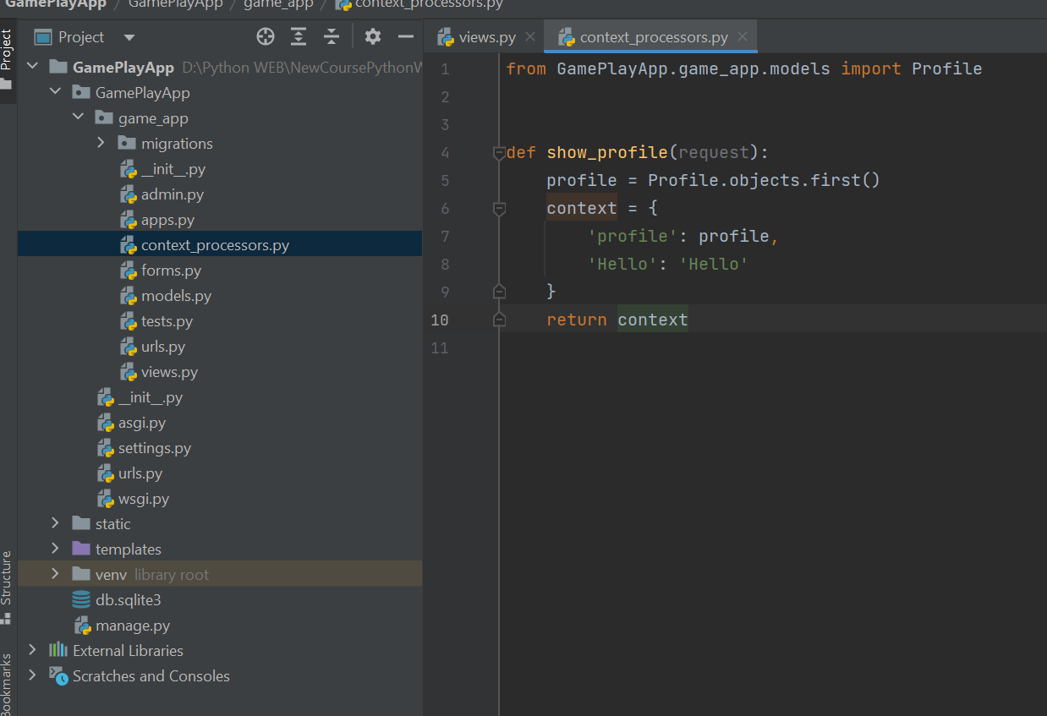

Step 3

Register context_processor.py and function in settings

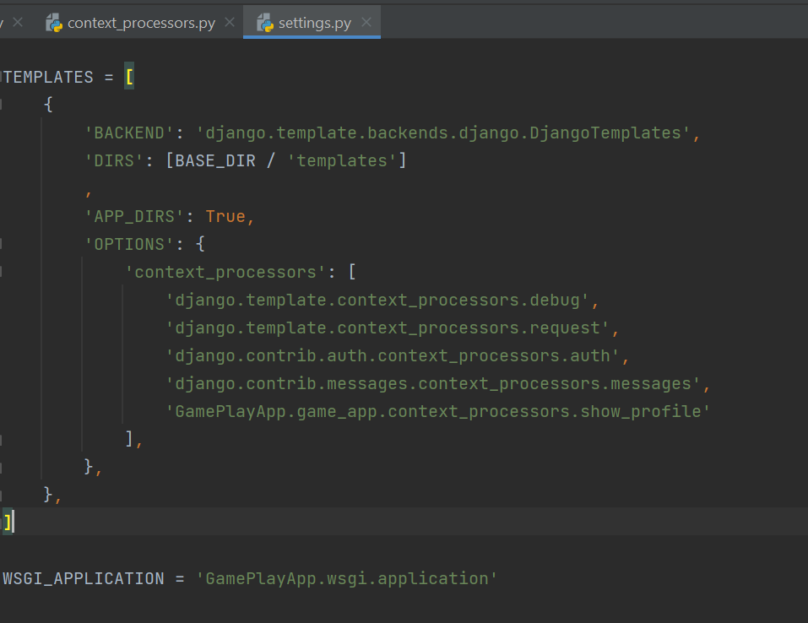

Step 4

Use data from context in your templates

<img class="game-img" src="{{ profile.image }}" alt='profile-image'/>  
{% endif %}  
<!-- user full name (if any) -->  
<h1>{{ Hello }} {{ profile.get_full_name }}</h1>  
<!-- user email -->  
<p class="text">{{ profile.email }}</p>  
<!-- user age -->  
<p class="text">Age: {{ profile.age }}</p>